CPT421 Final Project: Process lunch orders
Project must be submitted before the end of the last class session. Students may help other students during the design and coding. However, DO NOT share or give away your completed final source code. I encourage students helping students as this as how the developing world functions and you need to experience helping other developers. Just do not do all of another students work. The final exam includes all tutorials 1through 15.

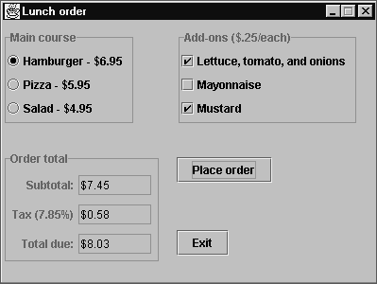

Operation
- For each order, the user selects one main course item and zero or more of the associated add-ons.
- When the user clicks the Place order button, the application displays the subtotal, tax, and total due for an order.
- When the user closes the frame or presses the Exit button, the application exits.

Add-ons
- The three add-ons are $0.25 each and change based on the main course that’s selected. In other words, when the user selects a radio button item, the text in the add-on changes to different values associated with the main course that is selected.
- For a hamburger, the three add-ons are (1) Lettuce, tomato, and onions, (2) Mayonnaise, and (3) Mustard.
- For a pizza, the three add-ons are (1) Pepperoni, (2) Sausage, and (3) mushrooms.
- For a salad, the three items are (1) Croutons, (2) Bacon bits, and (3) Bread sticks.

Process lunch orders (continued)

Specifications
- Create a class that sets up the frame. The frame should be centered on the screen. To help with the layout, start with a height of 300 and a width of 400 and adjust accordingly. This class should add a user-defined panel to the content pane.
- The panel class should contain instance variables for all components in the frame. The text fields should be 7 character-widths wide and the Hamburger radio button (or check box) should be initially selected (default selection) with a default add-on selection of mustard and lettuce, tomato and onions as displayed above.
- Add a Clear button that clears all data in the form and resets the form to the original defaults. The Clear button is not depicted on the example.
- Three graphics must be used. When the user selects a main course a graphic of the item should appear. Graphics are available on the Internet. In many cases the graphic may need to be sized to fit the application. Example: when the user selects Hamburger a graphic of a hamburger should appear. (Hint: Since the add-ons appear when a main course is selected, you may want to include the graphic with the add-ons.)
- The panel class should act as the event handler class for the button events.
- To help with the layout, first add the radio buttons to a panel. Add a border to this panel. Then, create a similar panel for the check box items and order totals and EXIT and calculate buttons. The final form doses not have to mimic the form above. However, the form should flow for the user and accomplish the events required. Experiment and have fun.
- The subtotal is equal to the cost of the main course item plus the cost of the add-ons. The tax is the subtotal * 0.0785 (Sales Tax rate). And the total due is the subtotal + tax.
- If a user deselects or changes the form the calculations should change appropriately.

Note: Shown in the example is the use of Radio Buttons to select the main course. Students may use check boxes but only allow one check box to be selected at a time. I suggest that students use JRadioButtons which is covered in Tutorial 17 beginning on page 429.
Note: To help with the layout, there are methods that use different layout managers. A little research can result in actually saving you time while expanding your knowledge of additional layout managers used in Java. The procedure is:
First add the radio buttons to a panel that uses the Border Layout manager and lay out the radio buttons in the NORTH, CENTER, and SOUTH fields. Add a border to this panel.
Then, create a similar panel for the check box items and order totals. For the order totals components, you can first add each label and text field to a separate panel using the Flow Layout manager with right alignment. Then, add these three panels to one larger panel using the Border Layout manager. Finally, layout the three panels and two buttons using a Grid Bag layout of 4 rows and 4 columns. I know this sounds crazy, but it will work, See below links or many other links on different layout managers:
http://java.sun.com/developer/technicalArticles/GUI/AWTLayoutMgr/
http://www.iam.ubc.ca/guides/javatut99/uiswing/layout/using.html
Note: Much time can be saved by using the concept of code reuse in JAVA. Think of an exercise or project you have completed. Can you change the project to fit the final?

